Laboratory Activity
Recursion
Objectives
At the end of this activity students are expected to:
- Identify the base case, recursive case, and state the change in recursive algorithm.
- Trace the execution of a recursive binary search algorithm.
- Implement a recursive binary search program that accepts user input.
- Modify a recursive function to display its execution trace.
- Explain how recursive calls return a value to the original caller.
- Understand and apply the three laws of recursion.
Background

There are many representation of recursion in art and nature. For example, fractal patterns are naturally recursive, the Russian Matryoshka dolls is a physical example of a recursion.

In Computing, Recursion is a fundamental technique in computer science, where a function invokes itself one or more times during execution, or by which a data structure relies upon smaller instances of the very same type of structure in its representation. It is an elegant ang powerful technique in performing repetitive tasks. Recursion does not simply repeat the same operation. Instead, a recursive function solves a problem by reducing it to a smaller version of the same problem until it reaches a condition that can be solved directly.

In designing a recursive algorithm, it must follow these 3 laws:

- A recursive algorithm must have a base case.
- A recursive algorithm must change its state and move toward the base case
- A recursive algorithm must call itself, recursively.

A classic recursive algorithm, binary search, is used to efficiently locate a target value within a sorted sequence of elements stored in an array. The binary search algorithm maintains two parameters, low and high, such that the candidate elements have indices from low through high. Initially, low = 0 and high = n - 1. The algorithm then determines the middle element using:

Standard formula;
Mid = [(low+high)/2]

The target value is then compared with array[mid]

Overflow-safe formula;

Mid = [low + (low + high)/2]
In Java, because low and high are integers, integer division is performed and any fractional part is discarded.

Consider the 3 cases:

- If the target is equals the median candidate, then we have found the item we are looking for, and the search terminates successfully.
- If the target is less than the median candidate, then we recur on the first half of the sequence, that is on the interval of indices from low to mid-1.
- If the target is greater than the median candidate, then we recur on the second half of the sequence, that is, on the interval of indices from mid + 1 to high.
An unsuccessful search occurs if low > high, as the interval [low,high] is empty.

Laboratory Activity
Specific Tasks:
Study the given program (In canvas LMS class, Midterm module text file named Binary Search), before proceeding with the tasks. Use the given program as the starting code for the following. Do not rewrite the algorithm from scratch unless instructed.
- In the given program, provide a recursion trace. Illustrate what is happening when the method is called. Recursion Trace: For each recursive call, record the values of low, high, mid, array[mid], and the action taken by the algorithm. Continue until the target is found or low > high.

A recursion trace closely mirrors a programming language’s execution of the recursion. You may use the same example shown in class or by using a table to illustrate. The use of any drawing tools or sites to illustrate the trace is allowed. Paste it below in the output section.

- Modify the given Java program for the Binary Search algorithm so that it accepts a user inputs:
  - the number of elements in the array
  - The elements of the array
  - and the “target value”
The program must perform the recursive binary search and display the array index of the target if it is found, if not, display -1. Screenshot the program and the output and paste it on the output section.
Binary search depends on a sorted sequence, array must be sorted in ascending order before search is performed.

- Modify the function in the program so that it displays the values of low, high, and mid during every recursive call. The trace must clearly show how the search interval becomes smaller after each recursive call.
Example output of the program(this is a fragment and not the whole output):
binarySearch(0, 9, 25)
binarySearch(0, 4, 25)
binarySearch(3, 4, 25)
binarySearch(4, 4, 25)

- Explain how to modify the recursive binary search algorithm so that it returns the index of the target in the sequence or -1 (If the target is not found). In your explanation, identify:
  - the base case that returns the index;
  - the base case that returns -1; and
  - how the recursive call passes its return value back to the previous call.
Note:
The following comment structure should be included in each program:
/* Description: <Describe what this program does briefly>
Programmed by: <your name> <course> <cn> <subject>
Last Modified: <date of latest revision>
Version: <version number>
[Acknowledgements: <list of sites and or sources, generative AI used and with the prompt>]
*/
Test cases:
Input | Expected Output | Your Output
Number of elements: 5  Array: 10 20 30 40 50  Target: 30 | Target found.  Index: 2 | Sorted array: [10, 20, 30, 40, 50]  Element found at index: 2
Number of elements: 8  Array: 5 10 15 20 25 30 35 40  Target: 10 | Target found.  Index: 1 | Sorted array: [5, 10, 15, 20, 25, 30, 35, 40]  Element found at index: 1
Number of elements: 15  Array: 3 7 11 15 19 23 27 31 35 39 43 47 51 55 59  Target: 44 | Target not found.  Index: -1 | Sorted array: [3, 7, 11, 15, 19, 23, 27, 31, 35, 39, 43, 47, 51, 55, 59]  Element not found.  -1
Number of elements: 1  Array: 25  Target: 10 | Target not found.  Index: -1 | Sorted array: [25]  Element not found.  -1
Number of elements: 7  Array: 40 10 70 20 50 30 60  Target: 50 | Sorted array: 10 20 30 40 50 60 70  Target found.  Index: 4 | Sorted array: [10, 20, 30, 40, 50, 60, 70]  Element found at index: 4

Questions:
Instructions: When answering the questions use a different font color any color except white or something close to white.
1. What are the three laws of recursion? Briefly describe each law.
- A recursive algorithm must have a base case to stop the recursion.
- It must change its state and move toward the base case.
- It must call itself recursively.
2. In the recursive binary search algorithm, what are the purposes of the variables low, high, and mid?
low is the starting index, high is the ending index, and mid is the middle index of the current search interval.
3. What are the two conditions that can cause the recursive binary search to stop? Explain what happens in each condition.
The search stops when the target equals array[mid], meaning the target is found, or when low > high, meaning the search interval is empty and the target is not found.
4. Why must the array be sorted before performing binary search? What could happen if an unsorted array is provided?
The array must be sorted because binary search uses the order of the elements to decide which half to search. With an unsorted array, it may search the wrong half and fail to find the target.
5. In Java, what is the difference between an array's index and its position? Give an example using the following array: {10, 20, 30, 40, 50}
An index starts at 0, while a position starts at 1. For example, 30 has index 2 and position 3.
6. A student modifies the recursive binary search program but accidentally writes the recursive call without changing low or high. Explain why this can cause a program to repeatedly call itself without reaching the base case. Which of the three laws has been violated?
If low and high do not change, the same search interval is checked repeatedly. The program may never reach the base case. This violates the second law, which requires the state to change and move toward the base case.
8. A student claims that: “binary search is better than linear search because binary search checks fewer elements.” Do you agree or disagree? Evaluate the statement and explain at least one situation where linear search may be more appropriate than a binary search.
I agree that binary search can check fewer elements, but it requires sorted data. Linear search may be more appropriate for a small or unsorted array because it does not require sorting first.
9. The program works correctly when the user enters a sorted array, but produces incorrect results when the user enters an unsorted array. What happens when the user enters an unsorted array, and how would you modify the program to address the problem?
Binary search may search the wrong half and produce an incorrect result. I would automatically sort the array before searching because binary search requires a sorted sequence.
10. How could you modify the program to automatically sort an unsorted array before performing binary search? What additional problem must you consider if the program is required to return the original index of the target?
I would use Arrays.sort() to sort the array before searching. However, sorting changes the positions of the elements, so the original index of the target may be lost. The original indexes would need to be saved if they are required.
11. Recursion can make a program shorter, but it can also make program execution harder to visualize. Based on this activity, when do you think recursion is an appropriate solution to a programming problem, and when might an iterative solution be preferable? Explain your reasoning.
Recursion is appropriate when a problem can be divided into smaller versions of the same problem, like binary search. An iterative solution may be preferable when the process is simple and can be repeated easily using loops.

OUTPUT
Task 1 – Recursion Trace
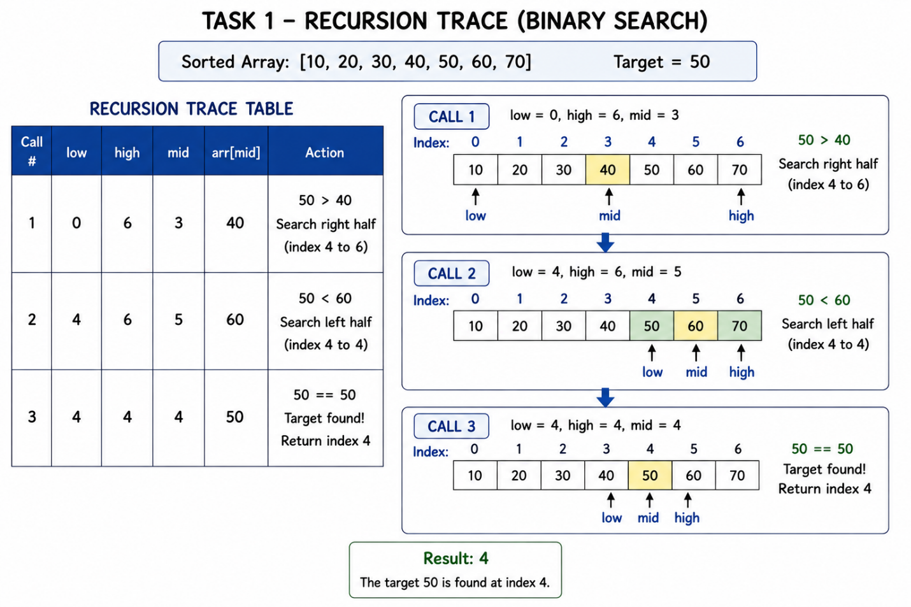

Task 2 – Modified Binary Search Program

Screenshot of your source code
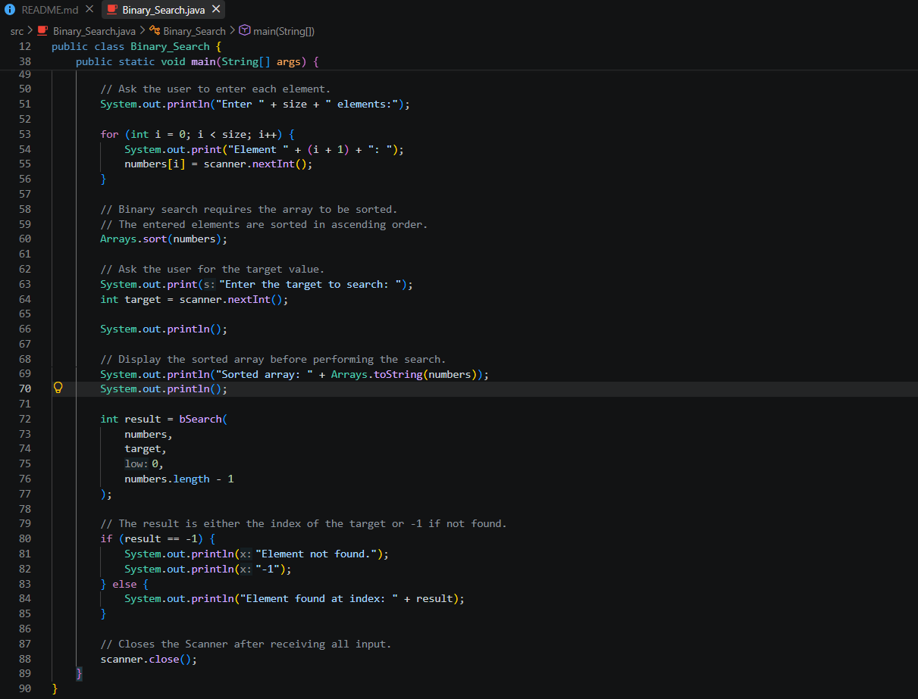

Screenshot of a successful search
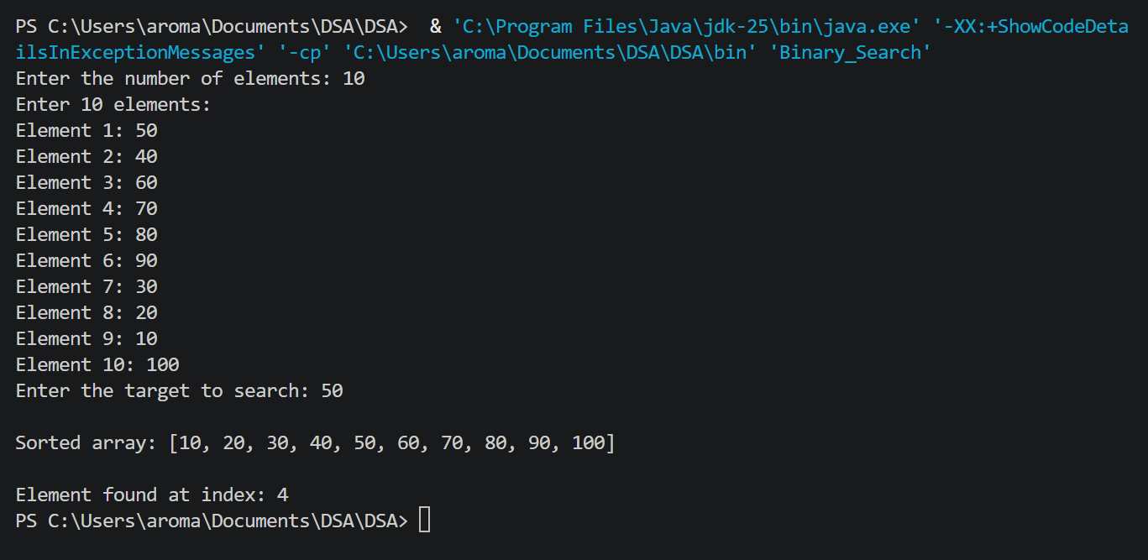
Screenshot of an unsuccessful search
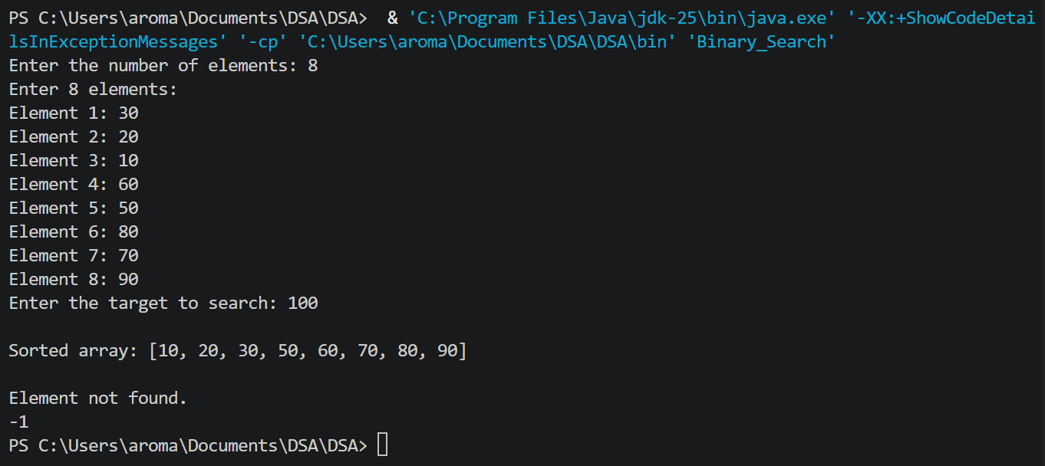

Task 3 – Search Trace

Screenshot of your modified source code
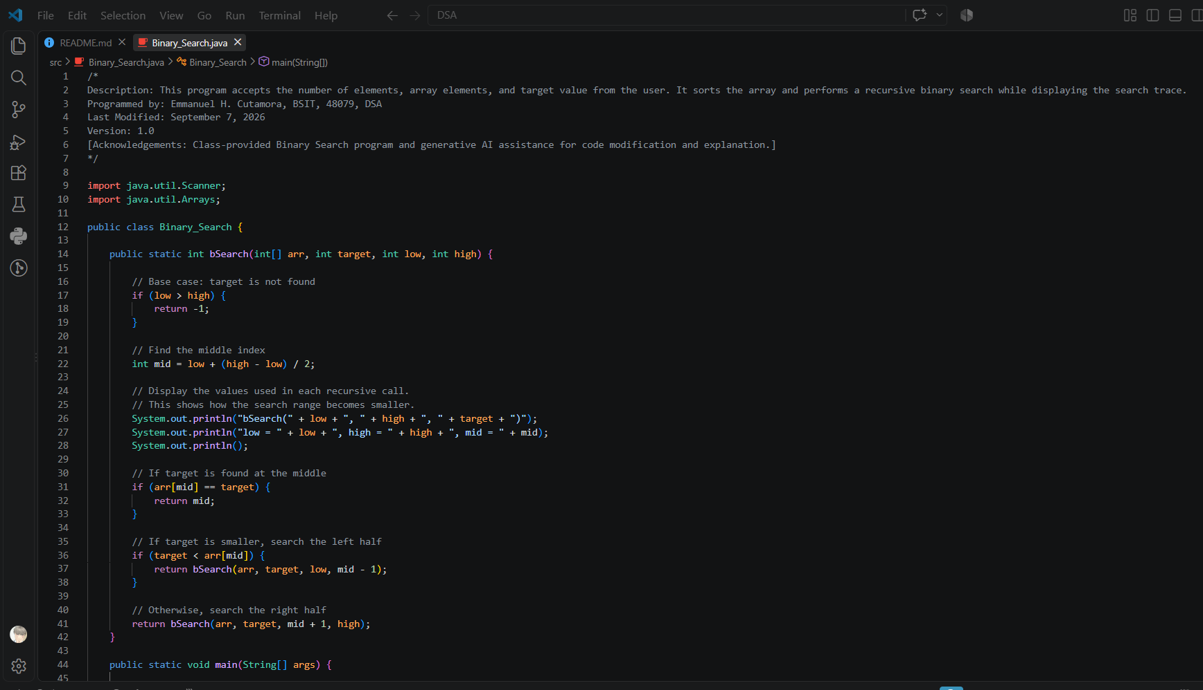

Screenshot of the program displaying the recursive search trace
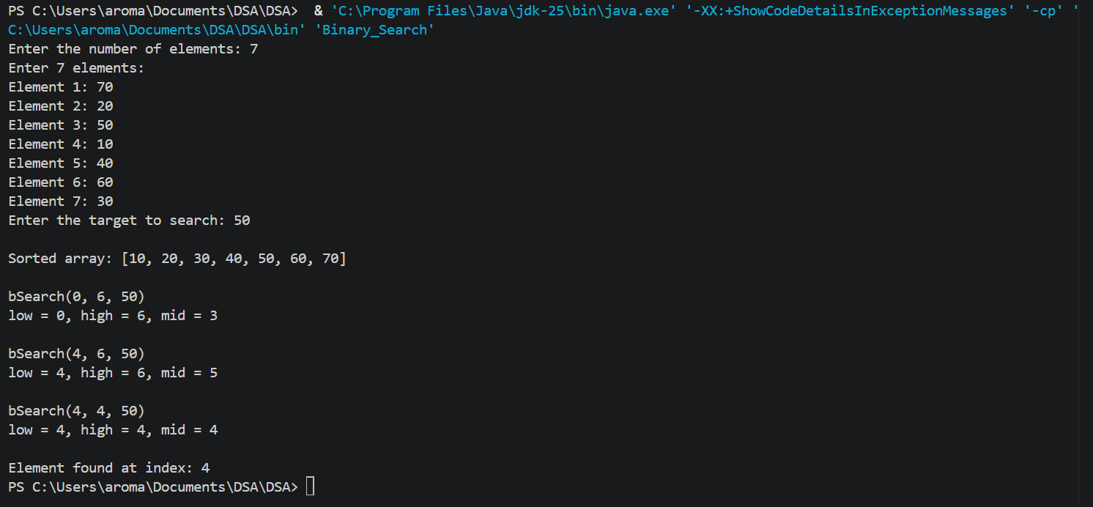

Task 4 – Explanation
Recursive binary search returns the target’s index when it is found and -1 when it is not found. When arr[mid] == target, the target has been found, so mid is returned as its index. When low > high, there are no more elements left to search, so -1 is returned. Each recursive call then searches either the left or right half and passes its result back to the previous call until it reaches main(). In this way, each call reduces the search area until the target is found or no elements remain.

AI DISCLOSURE STATEMENT:
- AI DISCLOSURE STATEMENT
- AI Tool Used: ChatGPT (GPT-5.6 Luna)
- Task Performed: AI was used to help explain recursion and binary search concepts, review parts of the program, and suggest possible improvements to the code and explanations.
- Extent of Use: AI assistance was used throughout the activity as a learning and checking tool, but the program was modified and completed based on my own understanding.
- Human Verification: I reviewed, tested, and verified the code, outputs, explanations, and answers before submitting them.
- Why and How AI Was Used: AI was used to better understand recursive calls, base cases, binary search, and how values are returned between recursive calls. It also helped me check whether my modifications followed the requirements of the activity.
- Estimated AI Assistance: Approximately 25% of the submitted work was assisted by AI.
- Changes Made to the AI-Assisted Output: I modified the code, comments, inputs, output format, test cases, explanations, and question answers to match the requirements of the activity and my own understanding.
- What I Learned: I learned how recursion reduces a problem into smaller parts, how binary search narrows its search range, and how a recursive function can return a value back to the original caller. I also learned how to trace recursive calls and understand what happens during each call.
Important: You are responsible for understanding and being able to explain every part of your submitted program.

